**Excel Assignment – 8**

**Q1: What do you mean by AutoComplete feature in Excel and what are the benefits of** **using this feature?**

Ans Autocomplete finishes words or phrases while typing. Benefits of using this feature is that it save so much time and reduce data entry errors.

**Q2: Explain working with workbooks and working with cells.**

Ans: Workbooks is a collection of one or more spreadsheets, also called worksheets, in a single file that can be accessed through the tabs at the bottom of the worksheet.

A worksheet consists of cells in which you can enter and calculate data. The cells are organized into columns and rows where rows are identified by number and columns by alphabets. Excel allows the user to enter any type of data in Excel cells, such as numeric, text, date, and time data. Whatever you enter in a cell, it appears inside the cell and as well as in the formula bar.

**Q3: What is fill handle in Excel and why do we use it?**

Ans: ‘Fill Handle’ is a tool that you can use to autocomplete lists in Excel.

For example, if you have to enter numbers 1 to 20 in cell A1:A20, instead of manually entering each number, you can simply enter the first two numbers and then hover the mouse over the bottom-right edge of the selection and drag it down .

**Q4: Give some examples of using the fill handle.**

Ans: 1. Use fill handle in excel to complete the list of numbers (that increment by 1).

2. Use fill handle in Excel to autocomplete weekday names. It could either be the three alphabets nomenclature (Mon, Tue…) or the full name (Monday, Tuesday…).

3. Autofill dates using the fill handle in Excel. Any date format that is recognized by Excel can be used by the fill handle.

**Q5: Describe flash fill and what the** **different ways to access the flash fill are.**

Ans: Flash fill is automatically extract or to automatically combine data. Flash Fill in Excel only works when it recognizes a pattern.

There are different ways to access the flash fill are:

1. Fill in the first cell and press Enter and then press Ctrl+E.
2. Fill in the first cell and press Enter. Click the Flash Fill button on the Data tab or press the Ctrl + E shortcut.

**Q6: Extract first name and last name from the mail id and then from the address column, extract the city, state, and pin code using the flash fill. Given below is an example of the columns you have to create. Paste the screenshot of what you have created using the flash fill command. Example: Mail Id, Address, First name, Last name, State, City, Pincode.**

Ans: Step1: Select the column and click on ‘text to columns’.

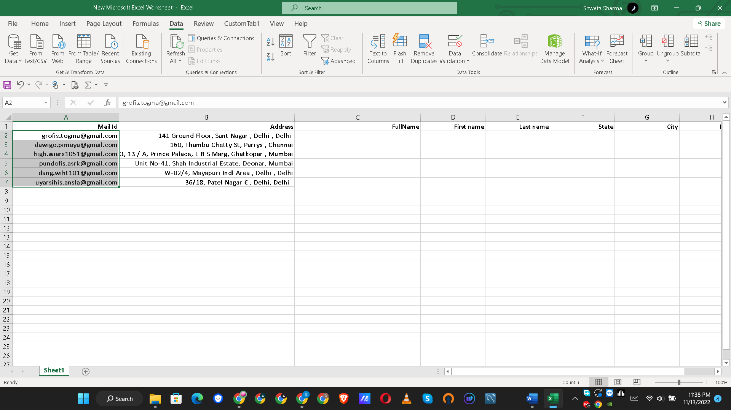

Step2: Choose delimiters

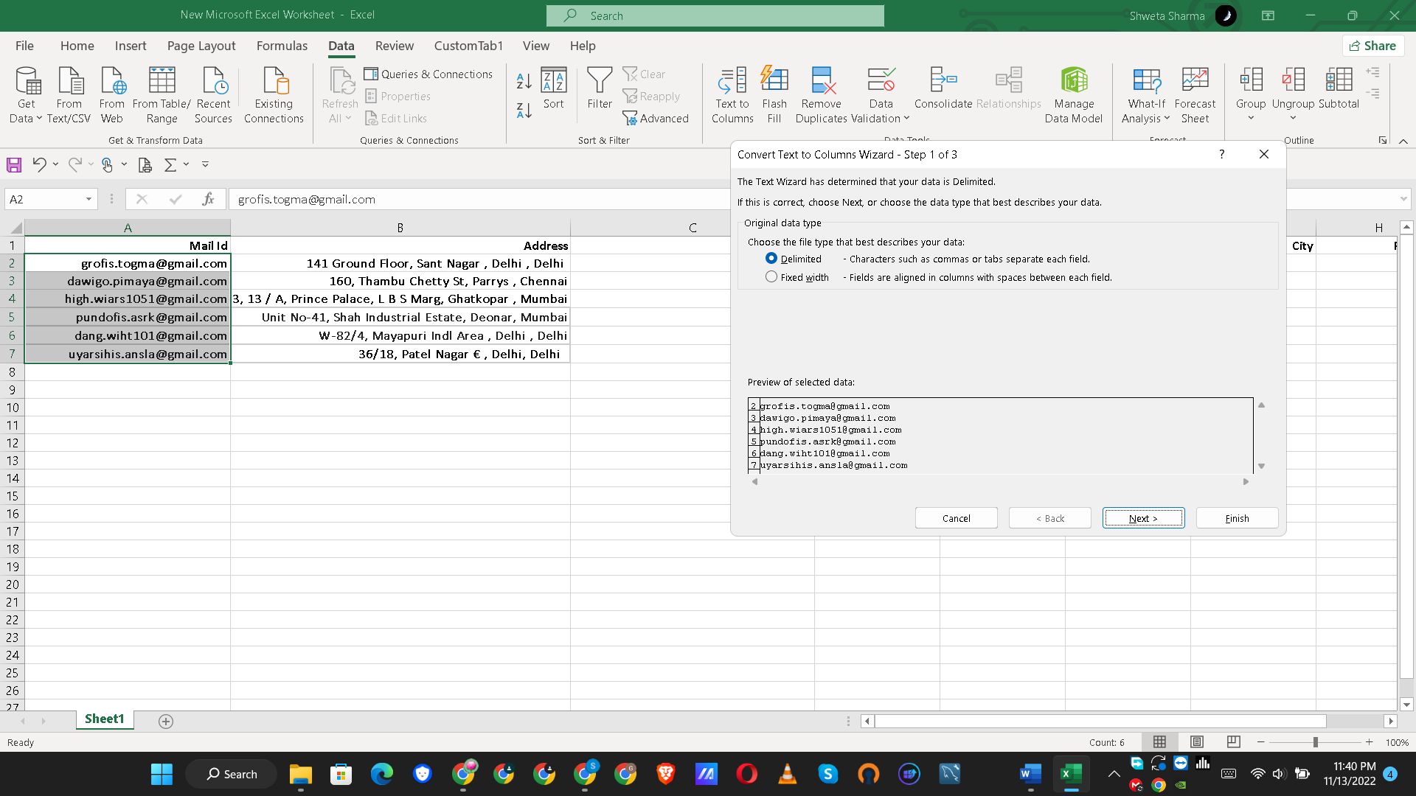

Step3: Choose delimiter as Other as @ to separate the email address.

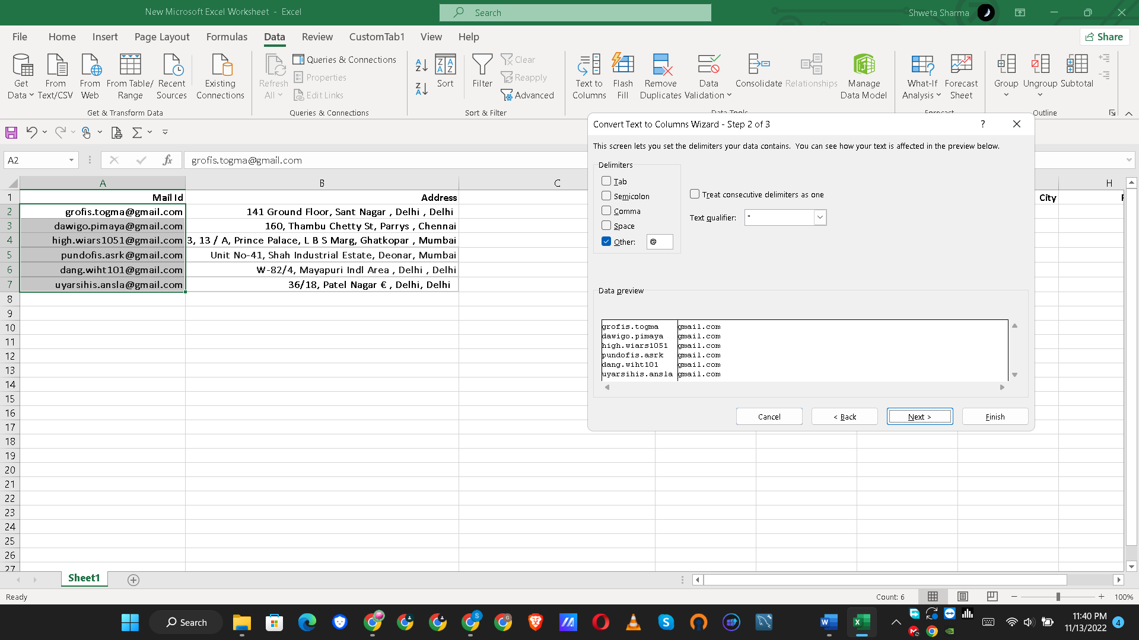

Step4: Now , we can get full name

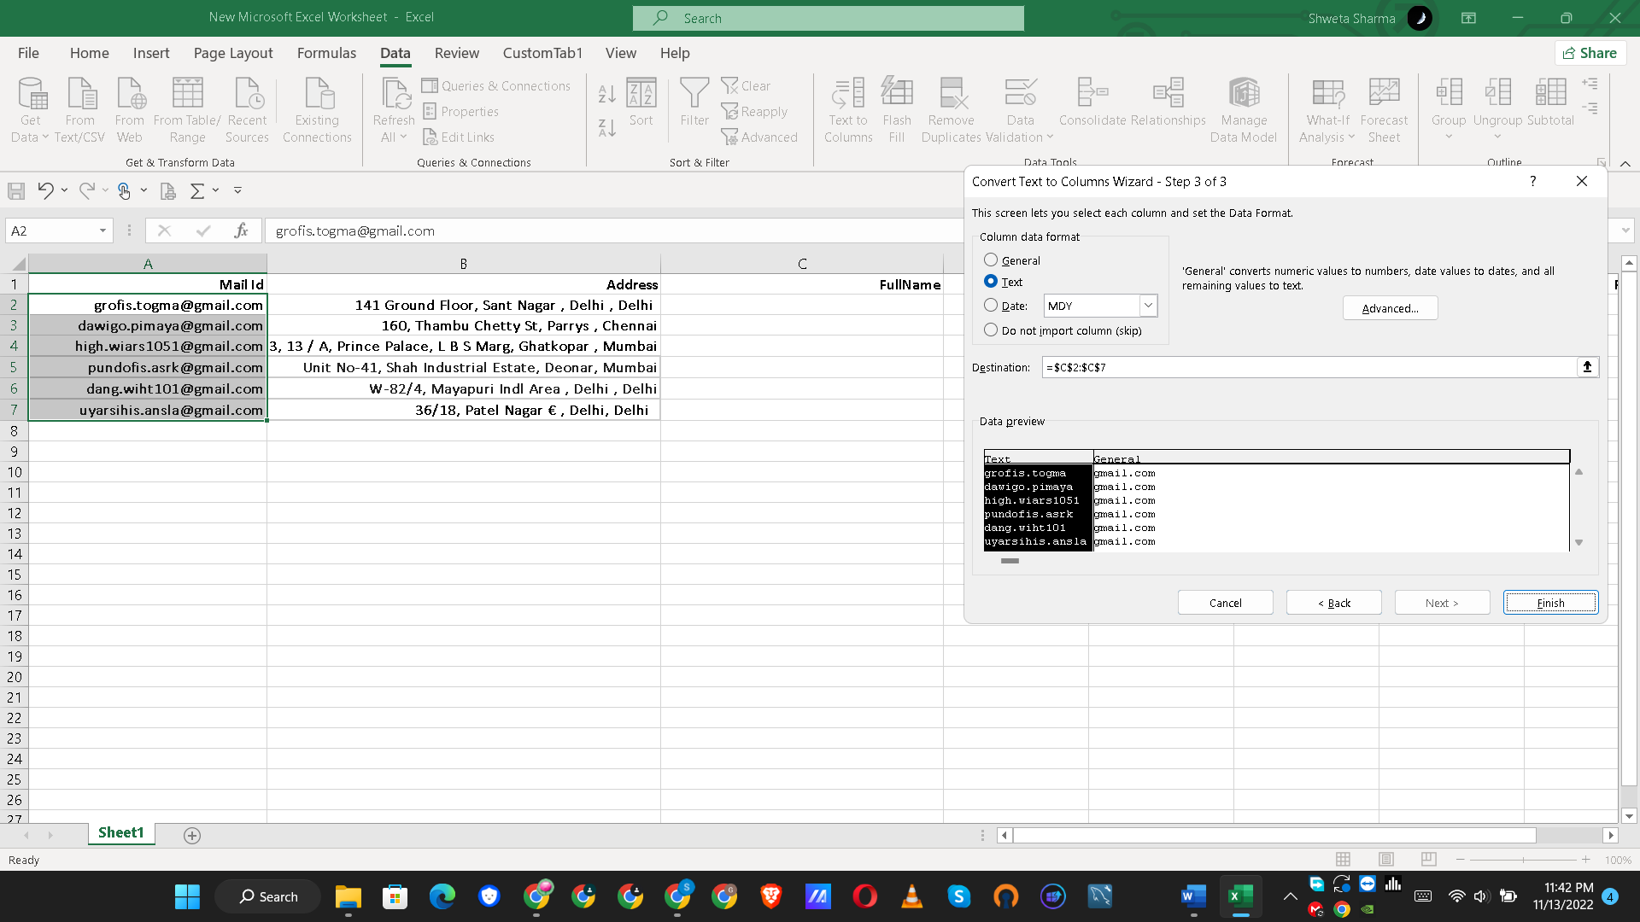

Step5: Use the ‘text to columns’ to separate the full name as first name and last name by dot .Steps are shown in below screenshots.

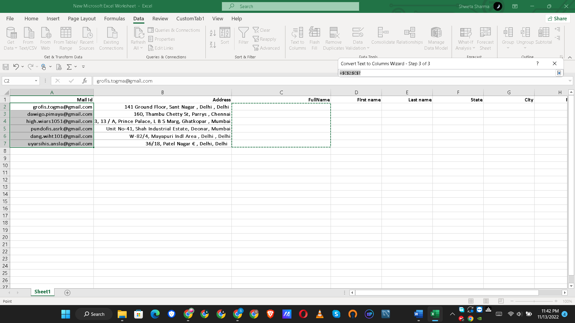

Step6:

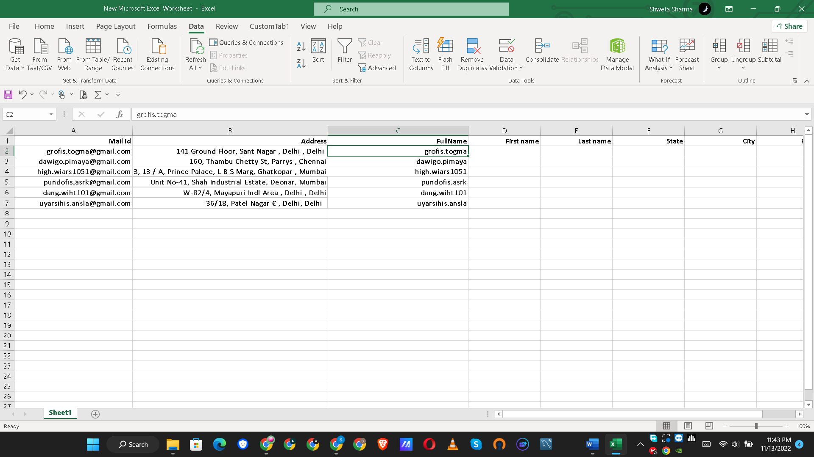

Step 7:

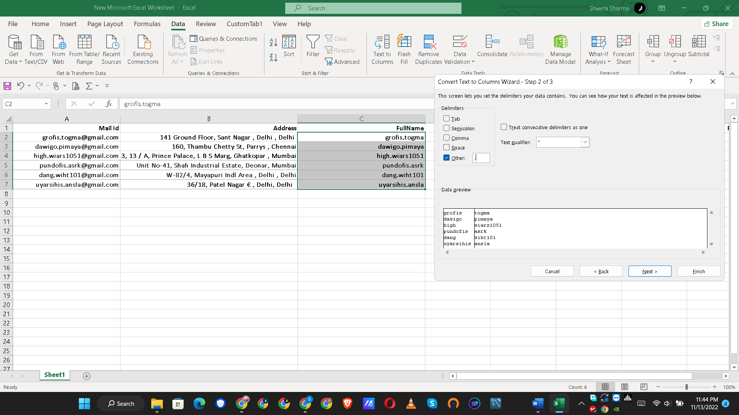

Step8 :

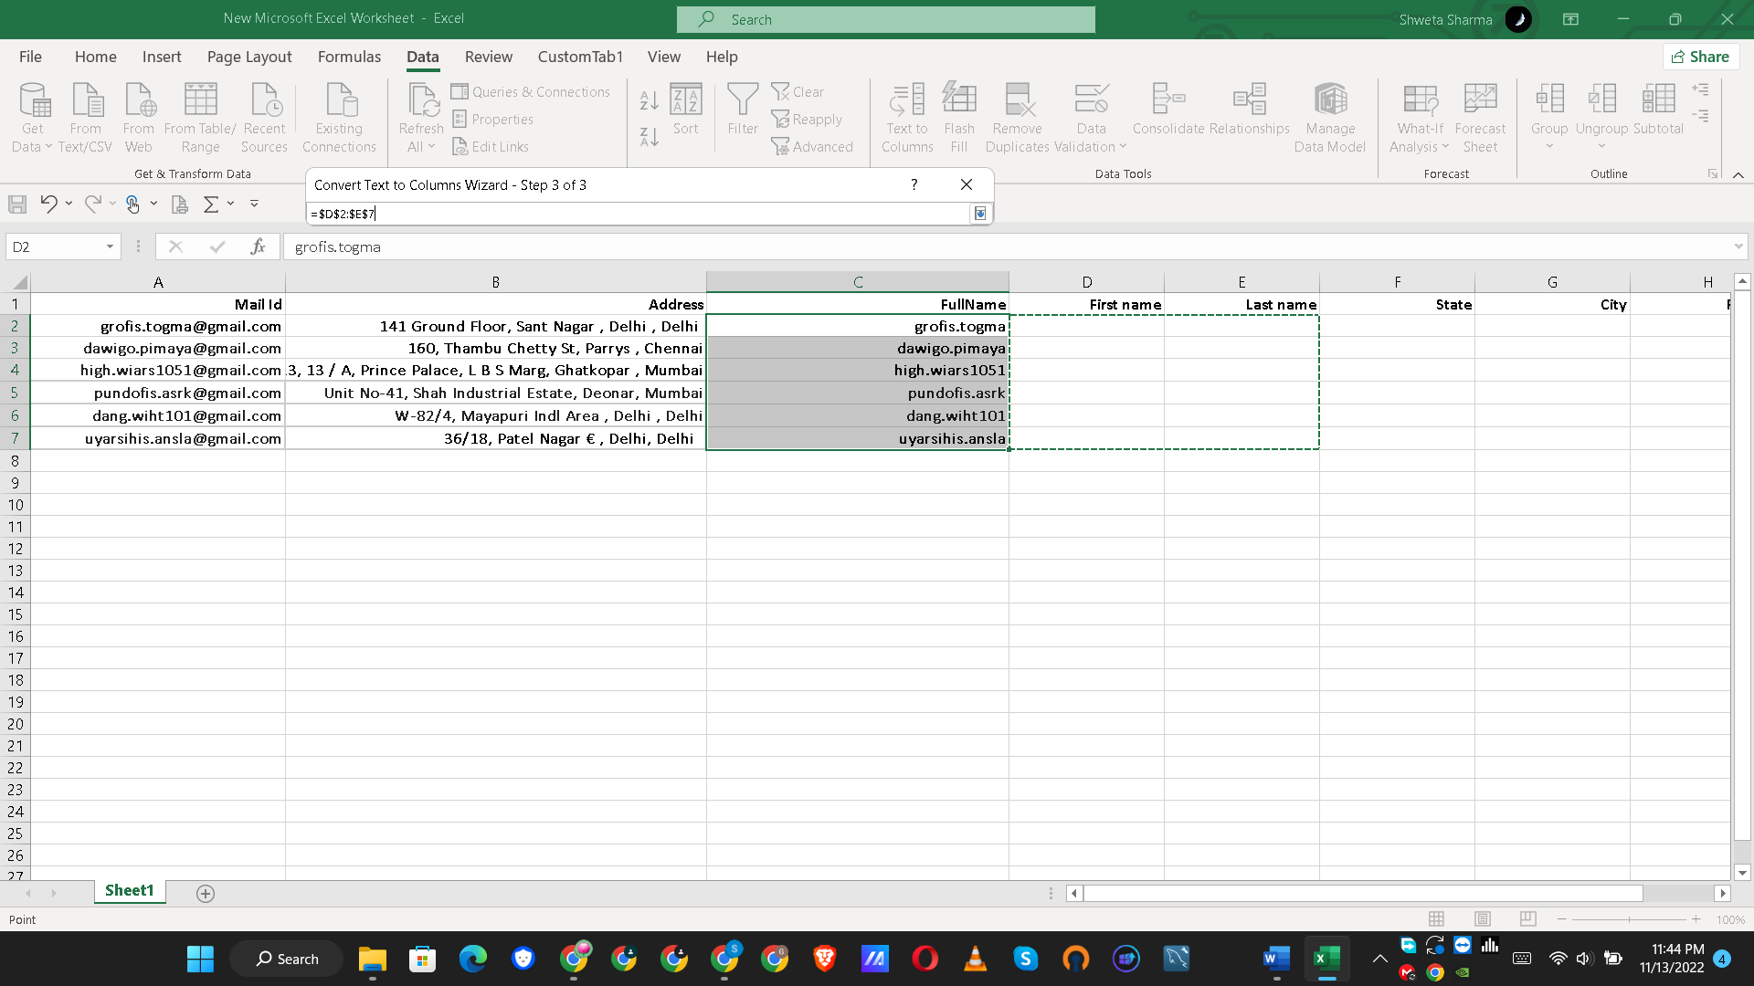

Step 9:

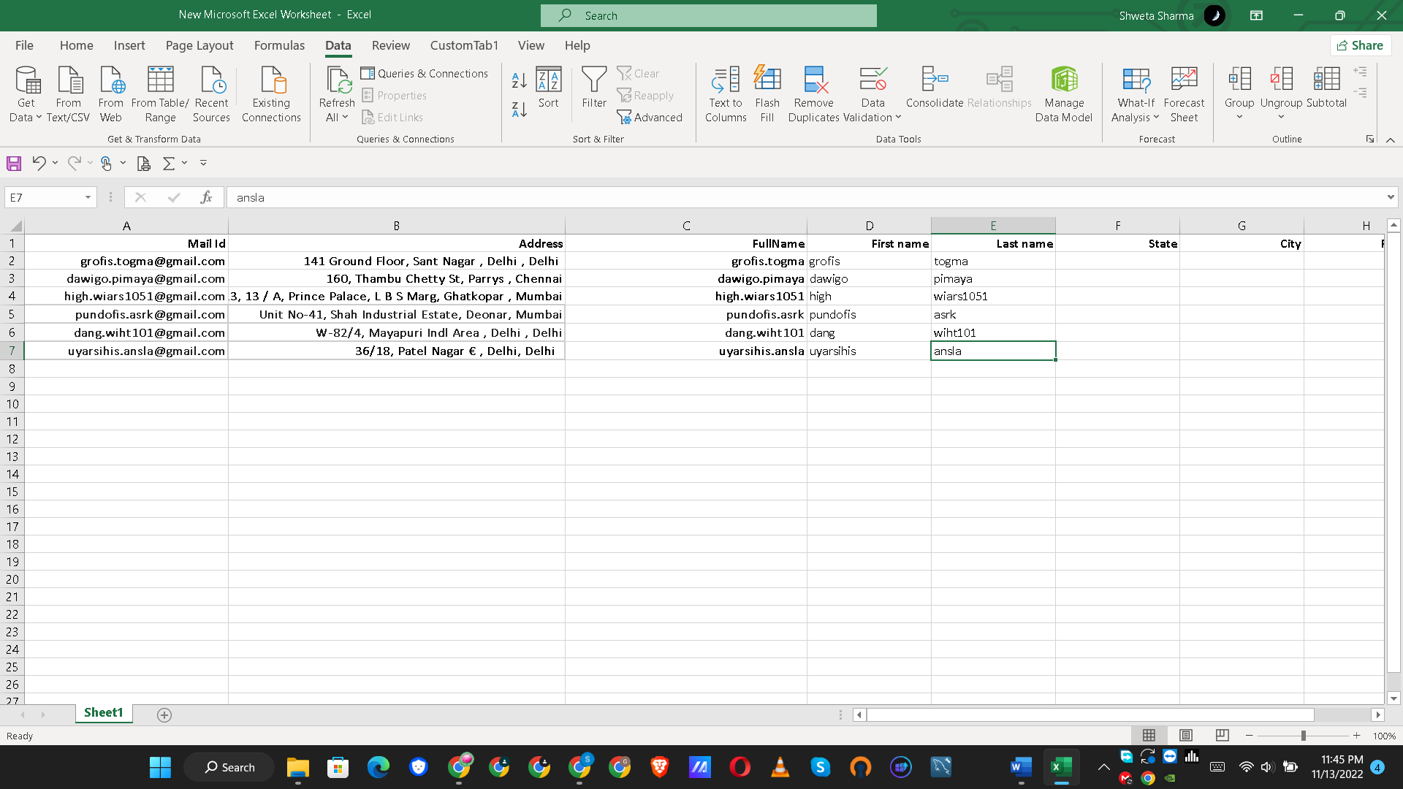

For Address:

Step 1: Fill first 2 cells

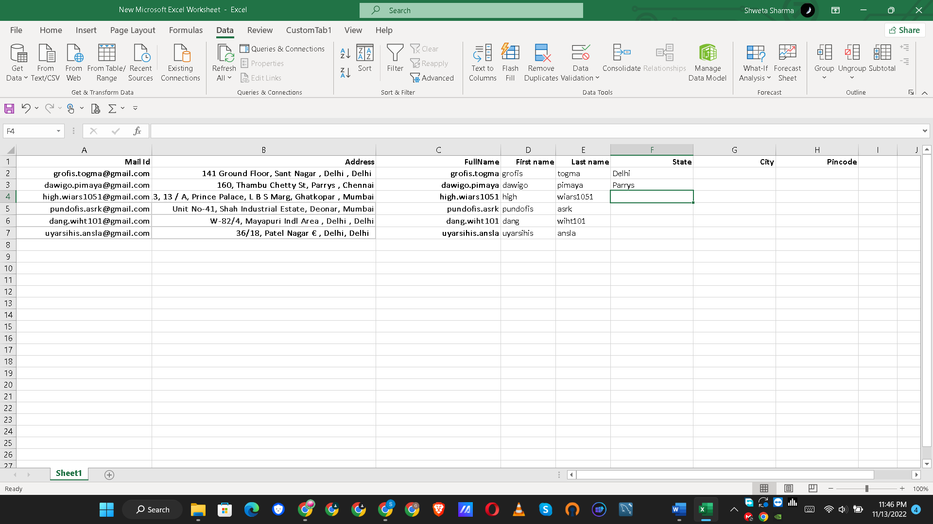

Then press Ctrl+ E

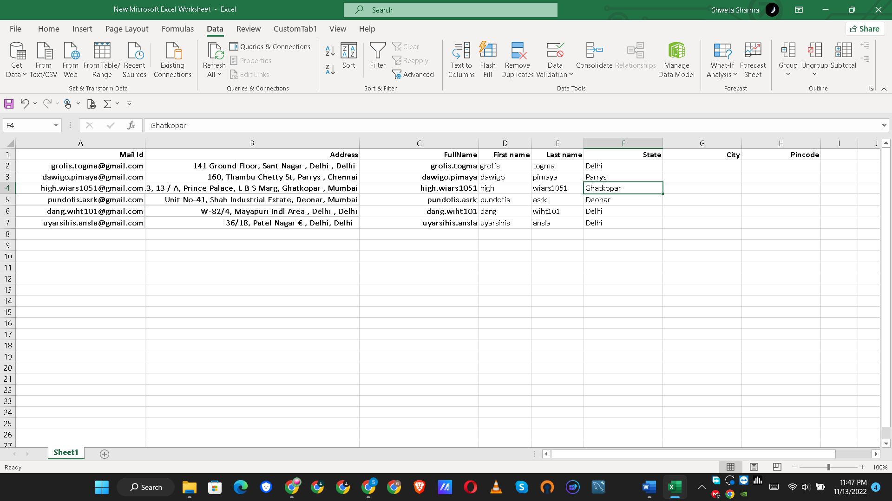

For city and pincode : Fill the first 2 cells and then press Ctrl+E.

